########################Checkpoint 4.1######################

1. Automobile, College Class, and Student are all entities because they need attributes to describe their details.

5. Attributes are details that describe an entity.

Automobile- Make, Model, Year, VIN

College Class- Credit Hours, Date, Time, Location, Course Number, Section

Student- Name, Student Number, Major

6. Relationships are the associations that link entities to one another.

####################Checkpoint 4.2#######################

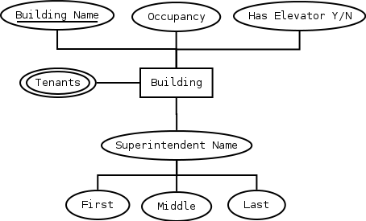

#####################Checkpoint 4.3##########################

1. Multivalued Attributes must be mapped in a separate table using the multivalued attribute and owner entity together to form a primary key. The multivalued attribute should not appear in the original table.
2. Composite Attributes should be mapped using their atomic parts as headings for separate columns.
3. Unique Identifiers are also called “Candidate Keys.” They can be made up of a single attribute or a combination of attributes and are usually underlined. They are called Candidate keys because they are candidates for the primary key. When there is only one, it will be called the primary key.

#####################Exercise 4.2 ############################

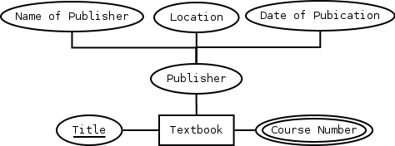

Entity = TEXTBOOK, *att*(1) = Title, *att*(2) = Course Number, *att*(3) = Publisher (Name of Publisher, Location, Date of Publication)

The Entity:

This database holds information about TEXTBOOKs. For Each TEXTBOOK in the database we record a Title, Course Number, and Publisher.

The Attributes:

For Each TEXTBOOK there will be one and only one Title. The value of Title will not be subdivided.

For Each TEXTBOOK there may be multiple Course Numbers. The value of Course Numbers will be represented on a separate table.

For Each TEXTBOOK there will be one and only one Publisher. The value of publisher will be divided into Name of Publisher, Location, and Date of Publication.

The Keys:

For Each TEXTBOOK we assume that there will be a unique Title that will be used to identify individual TEXTBOOKs.

Publisher is a Composite Attribute consisting of the Publishing Company, Location, and possibly the Publication Date.

Course Number is a Multivalued Attribute because the Textbook could be used for more than one Course.

I did not find any Derived Attributes.

Title would be a good Primary Key to use.

